**Name: Hashim Nadeem**

**RolNo: SU92-BDSFM-F25-001**

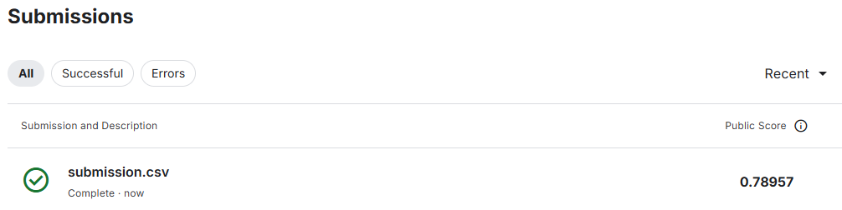

**Work Performed**

1. **Data Loading**
   * Imported the required libraries: pandas, train_test_split from scikit-learn, and RandomForestClassifier.
   * Loaded the provided datasets:
     + train.csv for training data
     + test.csv for testing data
     + sample_submission.csv as the template for the final submission
2. **Feature Engineering**
   * Created a new feature **CabinDeck** by extracting the first part of the Cabin column.
   * Created a new feature **TotalSpend** by summing up spending columns (RoomService, FoodCourt, ShoppingMall, Spa, VRDeck).
3. **Data Preparation**
   * Defined features (X) by dropping unused columns (PassengerId, Name, Cabin, Transported) from the training data.
   * Defined the target variable (y) as the Transported column.
   * Prepared the test features (X_test) by dropping unnecessary columns.
   * Converted categorical columns into numerical form using **one-hot encoding** (pd.get_dummies), ensuring training and test data had matching columns.
4. **Model Training**
   * Initialized a **Random Forest Classifier** with 200 trees and a fixed random state for reproducibility.
   * Trained the model on the prepared training data (X, y).
5. **Prediction and Submission**
   * Used the trained model to make predictions on the test dataset (X_test).
   * Created the final submission file by copying the sample submission and inserting predictions.
   * Saved the predictions as **submission.csv**.
6. **Accuracy**: 0.80